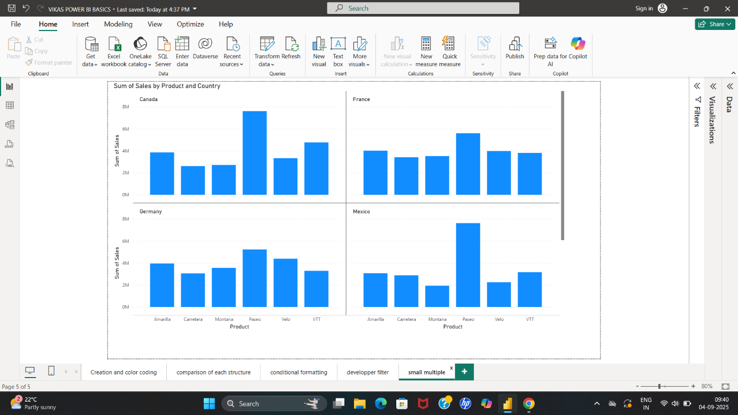

It’s a 5th day assignment in the power bi session about small multiple in the developer filter.